DRAFT NEGF26-XX
Title of the extended abstract. please replace Above “XX” with the reference number of your abstract. Centered, 14 Point, Capital Bold, "Title" style
First Name1 LastName1¹, First Name2 LastName2*, First Name3 LastName3²
¹Mailing address12
firstname.name@firm.country1, firstname.name@firm.country2
²Mailing address3
firstname.name@firm.country3

KEY WORDS
Place here a list of significant key words separated by commas. Avoid repeating words already mentioned in the title of the paper.

Abstract
This is the template file for preparing an 2-4 extended page abstract. You are requested to follow closely the following instructions.

The manuscript should be typewritten in a single column using Times New Roman font, on the A4-sized sheets with the left and right margins set to 2 cm and top and bottom margins set respectively to 1.7 cm and 2 cm. The text should be typewritten with single spacing throughout the manuscript. The number of pages should not exceed 4 pages.
The size of the electronic file should not exceed 1.5 MB after conversion to the PDF format. The author is responsible for the quality of the pdf conversion. Papers sent in docx or RTF format will be converted to PDF with no guarantee of the result.

Formulas
Equations should be centered and should be numbered consecutively using Arabic numbers in parentheses in the right-hand margin. This is automatically done if you use the appropriate style (Centered Formula) which provides a centered tab for the formula and a flushed right tab for the equation number:
$v=\frac{d}{t}$ (1)
where $v$ denotes the velocity (m/s), $d$ is the distance (m) and $t$ is the time (s). Blank lines should not be placed before and after the equation(s) if the same paragraph is continued. Please define all the variables and their unit immediately after their first occurrence in the text as shown for Eq.(1). Refer to an equation by using its number enclosed by parentheses.

Tables and Figures
All Figures and Tables must be referenced in the text and the captions should be flush left or may be centered below the figure or the table if it is less than one line long. The word Table or Figure must be printed in bold style. Use a single blank line after and before figures or tables. They may also be included with their caption in an array with one line and one column. In this case, do not allow the splitting of cells on different pages. This procedure allows a simpler placement of the Figures and Tables with their caption in the text. You should refer in the text to each table and figure as Fig.1 or Tab.1.
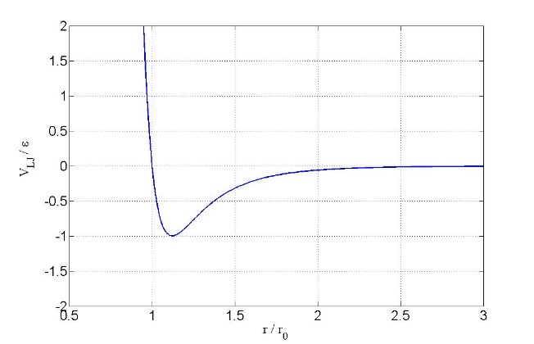

Figure 1: Example figure. Color can be used.

Experiment | Length, (m) | Velocity, (m/s) | Temperature, (K)
Case 1 | 1.0 | 2.50 | 300
Case 2 | 10. | 1.50 | 320
Case 3a | 5 | 10.0 | 300
Case 3b | 5 | 10.0 | 400

Table 1: Example table. Experiments nomenclature

When importing Figures or any other image, make sure of two things: (a) any number, text, or symbol is in Times font and is not smaller than 10-point after reduction to the actual window in your paper; (b) it can be printed in Postscript by Windows Word.

Acknowledgments
Acknowledge the help of colleagues, and sources of funding, if any.

References and Citations
References to published literature should be quoted in the text by enclosing between two brackets the number of the reference. Please refer to the following examples:

[1] Collier, J. G., & Thome, J. R. (1994). Convective boiling and condensation. third edn. Oxford: Clarendon Press.
[2] Delhaye, J. M., Giot, M., & Riethmuller, M. L. (1981). Thermal-hydraulics of two-phase systems for industrial design and nuclear engineering. Hemisphere and McGraw Hill.
[3] Lamb, H. (1932). Hydrodynamics. Cambridge University Press.
[4] Zwick, S. A., & Plesset, M. S. (1954). On the dynamics of small vapor bubbles in liquid. J. Math. Phys, 33, 308-330.

* Corresponding author

